**PCB board fabrication**

**Board name SFP_RFoF_GBR 2025-07-22 15-54**

|  |  |
| --- | --- |
| **Material** | FR-4 TG≥150 |
| **Finished board thickness** | 1.6mm+/-10%. |
| **Finished copper thickness** | 18um on both outer layers and 18um base copper in inner layers |
| **Solder mask** | Black color |
| **Silkscreen** | White color |
| **Surface finish** | HASL-lead free |
|  |  |
|  |  |

**Required PCB Stackup**

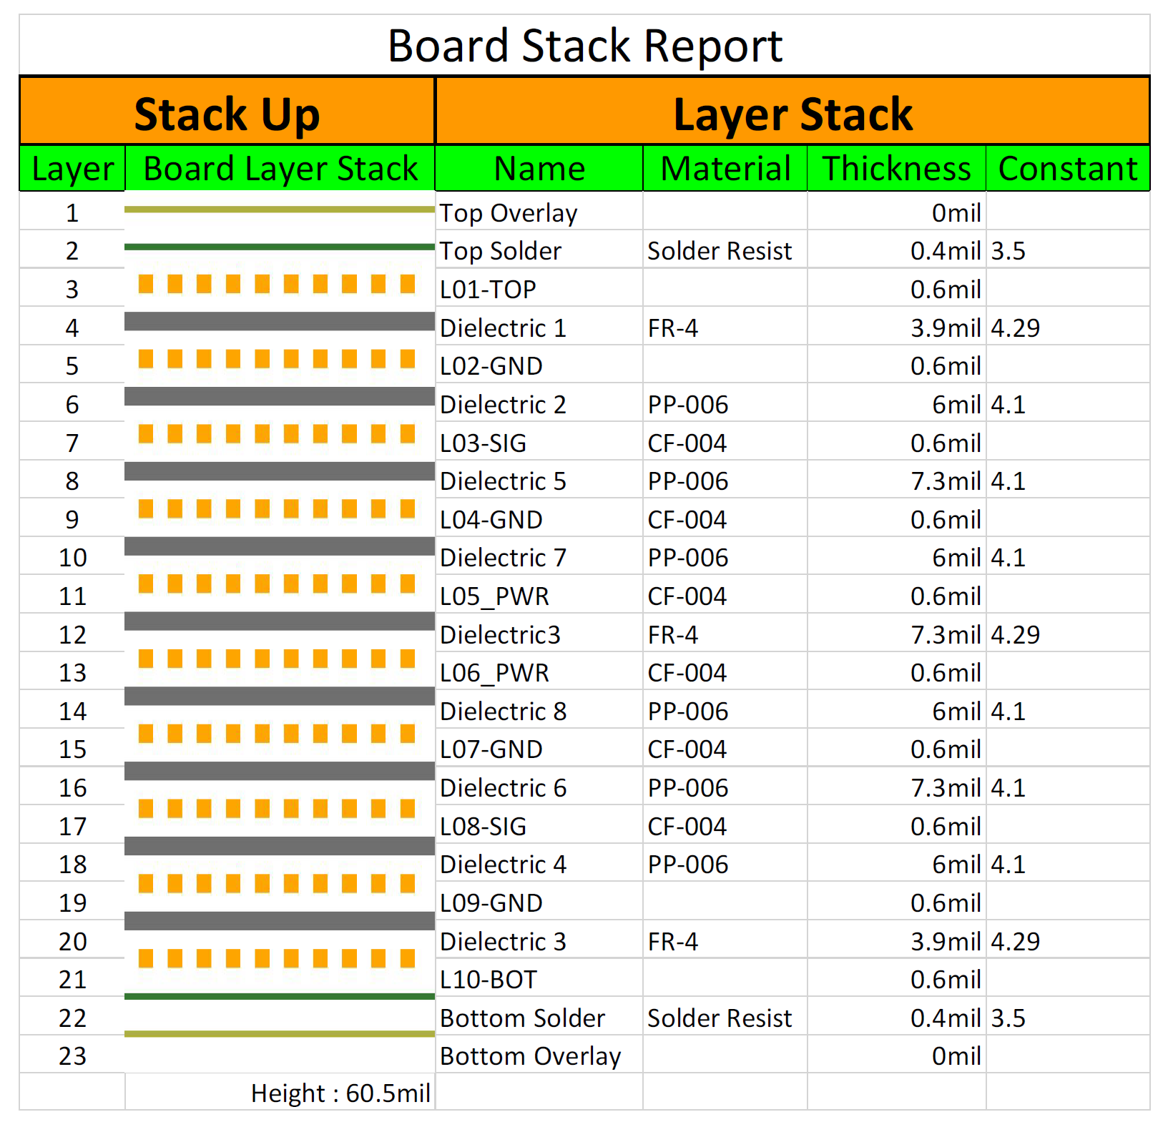

**Impedance constraints**

|  |  |  |  |  |  |  |  |  |  |
| --- | --- | --- | --- | --- | --- | --- | --- | --- | --- |
| № | Type | Layer | Design Line | Actual Line | Spacing | Ref Lyr | Target | Toler | Predicted |
| 1 | Single | Lyr1 | 6 | 6 |  | 0/2 | 50 | 5 | 53.46 |
| 2 | Single | Lyr3 | 5.5 | 5.5 |  | 2/4 | 50 | 5 | 50.86 |
| 3 | Single | Lyr8 | 5.5 | 5.5 |  | 7/9 | 50 | 5 | 50.86 |
| 4 | Single | Lyr10 | 6 | 6 |  | 9/0 | 50 | 5 | 53.46 |
| 5 | Diff | Lyr1 | 5 | 5 | 10 | 0/2 | 100 | 10 | 116.48 |
| 6 | Diff | Lyr3 | 5 | 5 | 8 | 2/4 | 100 | 10 | 98.7 |
| 7 | Diff | Lyr8 | 5 | 5 | 8 | 7/9 | 100 | 10 | 98.7 |
| 8 | Diff | Lyr10 | 5 | 5 | 10 | 9/0 | 100 | 10 | 116.48 |